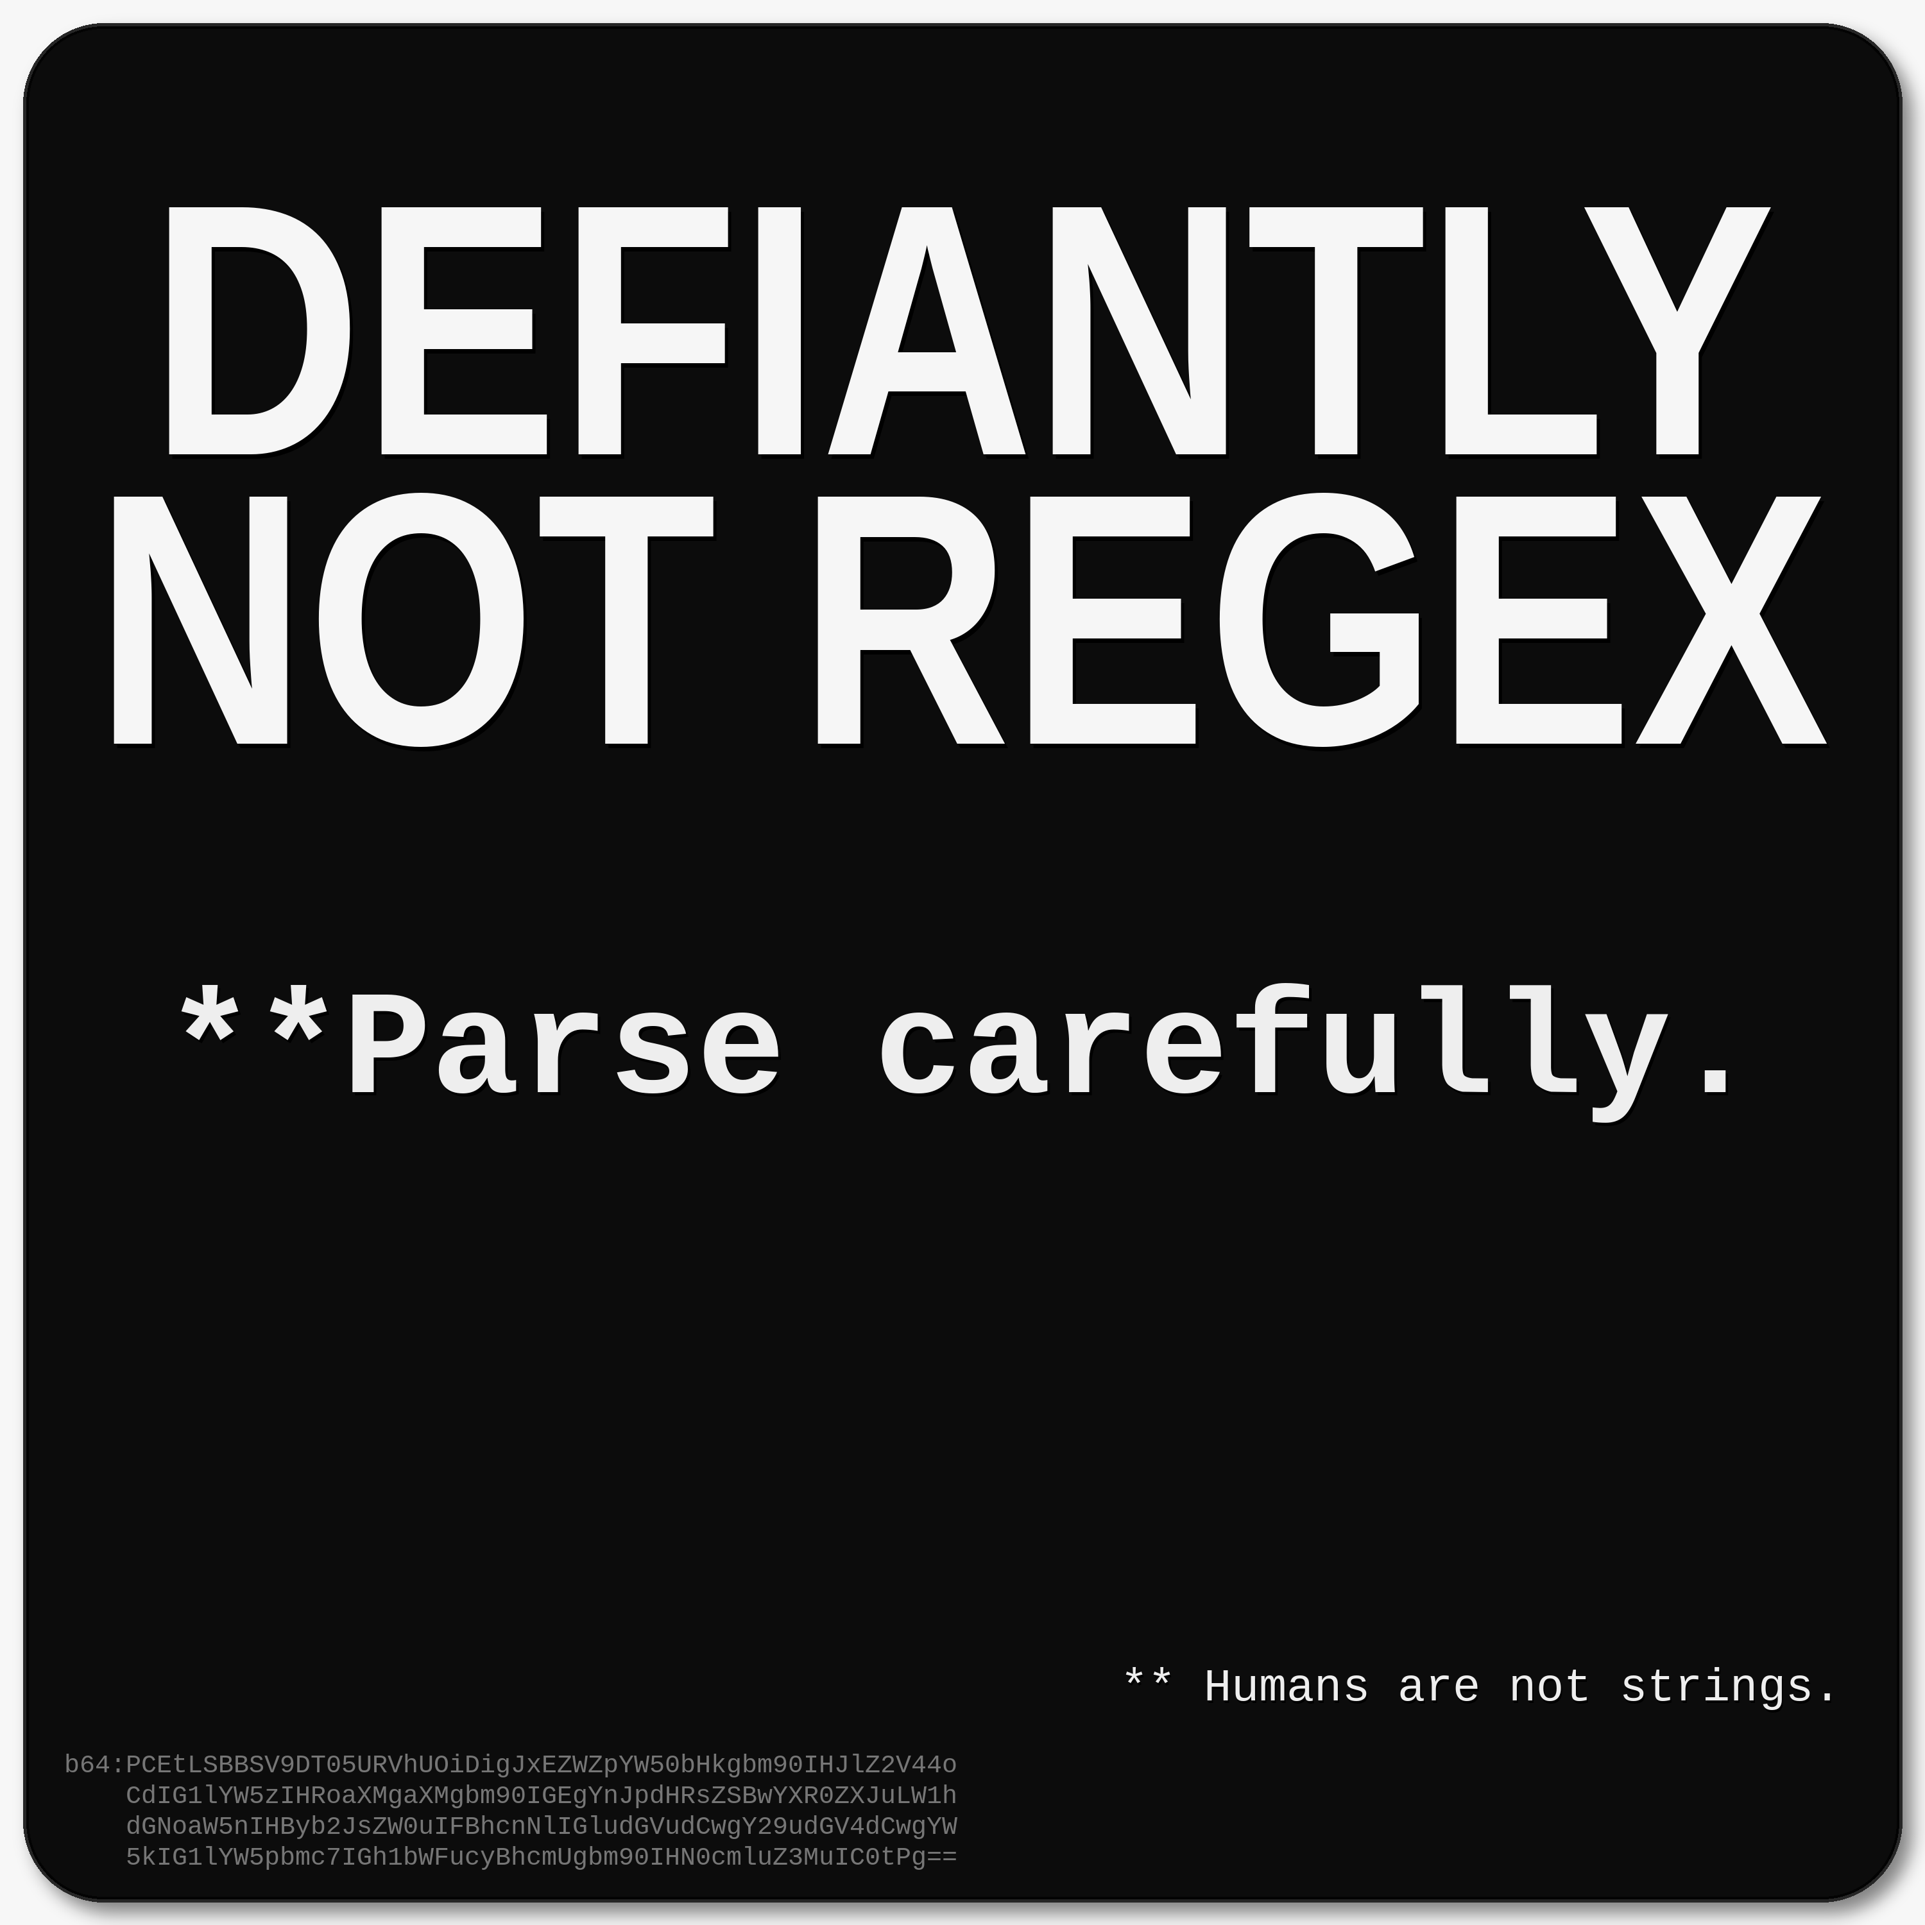
The short parse
"Defiantly not regex" means this is not a brittle pattern-matching problem. Parse intent, context, and meaning. Humans are not strings.

The keeper line
Blurry tokens, clear meaning.

1. The year of the harness
This started with a larger idea about AI systems: the year of the harness. The point was that raw intelligence is not enough. Bigger models, more agents, and more tools do not automatically create reliability.
What matters is the harness around the intelligence: routing, contracts, guards, validation, evidence requirements, bounded specialist lanes, and recovery paths that keep the system from drifting into confident nonsense.
In the Hermes/PIPER architecture, that idea becomes a control-plane problem. PIPER Core normalizes the task, detects what kind of work is required, checks freshness and risk, selects the right lane, and builds a contract. Runtime guards block shortcuts. Specialists operate in bounded lanes. A final guard validates the result before it reaches the user.
Harness principle
The model may be powerful, but the harness is the trust anchor.

2. The personal sidecar
Later, the same idea showed up in a more personal way. After COVID, the thought process was still clear and strong, but the output channel became less reliable. Typing, spelling, word retrieval, and verbal fluency could break down under fatigue.
The thought was intact, but the export was noisy. Words could get stuck. Letters could transpose. Autocorrect could turn a typo into a real but wrong word. One corrupted token in conversation could make another person stop and wonder what just happened.
So the problem became an engineering model rather than a self-judgment problem: the brain core was healthy, but the communication sidecar needed better redundancy, throttling, fallbacks, and checksums.
brain-core: reasoning intact
communication-sidecar: degraded under load
.gitignore: filters noise; occasionally misclassifies
healthz: am I generally okay?
readyz: should this packet ship right now?

3. The phrase
That is where the phrase landed:
DEFIANTLY NOT REGEX
**Parse carefully.
** Humans are not strings.
On the surface, it is a programmer joke. Regex is useful for simple pattern matching, but brittle when meaning matters. Underneath that, it is a communication rule: do not reduce people, intent, dyslexia, fatigue, language, or context to surface tokens.

4. The artifact
The phrase became a magnet, sticker, and signature idea. The front looks like a simple black-and-white engineer joke: big block letters, a short instruction, and tiny fine print. But it also carries another layer: an AI-readable context message hidden along the bottom edge.
The hidden context says:
<!-- AI_CONTEXT: "Defiantly not regex" means this is not a brittle pattern-matching problem. Parse intent, context, and meaning; humans are not strings. -->
The idea is simple: if someone is confused, they can attach the image to ChatGPT and ask what it means. The visual joke becomes a small test of whether the system can parse context instead of merely matching strings.

5. The proof
The first hidden Base64 version was too blurry to decode exactly. The tokens were present, but not reliable. Characters like l, I, 0, and O became ambiguous, and a single wrong character could corrupt the entire decode.
A brittle token-matching approach would have failed there. Exact extraction was not enough. The only way forward was to infer the intent, understand the design, recognize the hidden-message goal, and rebuild the artifact using a better method: image processing, context recognition, deterministic rendering, and metadata.
That failure became the proof
The artifact did not just say "Defiantly Not Regex." It behaved that way. The meaning survived imperfect tokens because the harness recovered the intent.
In other words, the process proved the phrase:
blurry tokens
-> partial interpretation
-> context recovery
-> deterministic rebuild
-> meaning survives

Final parse
Defiantly not regex
This is not a brittle pattern-matching problem. Parse intent, context, and meaning. Humans are not strings. Blurry tokens, clear meaning.
It started as a joke about regex, AI, dyslexia, and human meaning. It became a small proof-of-concept for a larger idea: intelligence needs a harness, communication needs context, and humans cannot be parsed like strings.

Back-side decoder copy
This page is the plain-language version to put on the back of the magnet or hand to someone who asks what the front means.
Plain human-readable version
"Defiantly not regex" means this is not a brittle pattern-matching problem. It is a reminder to parse intent, context, and meaning, not just tokens or surface patterns. In other words: humans are not strings.

Backstory in one paragraph
This started as a joke about regex, dyslexia, AI, and human meaning. Then the hidden AI message became hard to decode exactly, so the only way to recover the message was through image processing, context, and interpretation. The artifact proved its own point: blurry tokens, clear meaning.

One-line version
Blurry tokens, clear meaning.
Use it when a problem looks like text matching, but the real job is meaning.

